Self-Reflection
- What are your strengths and superpowers (beyond functional expertise)?
- I am a very quick learner, have high business acumen, and execute quickly.
- What are your weaknesses? How do you compensate for them?
- Prone to overanalysis. I like to do a lot of fact gathering before making decisions. I have begun to compensate by defining if it’s a one way door or two way door and giving myself a threshold of 70% to make a decision.
- I can lean walk/run in a crawl walk run concept. I can be prone to overengineering. I have begun to ship quicker and let market feedback dictate next steps.
- I have limited sales experience. I am using an AI CRM and a tool I built to enhance my skillset and ramp quickly on elements of sales like discovery and objection handling.
- How do you deal with conflict? Describe a time you dealt with it well — and a time you didn’t.
- I believe in the concept of radical candor
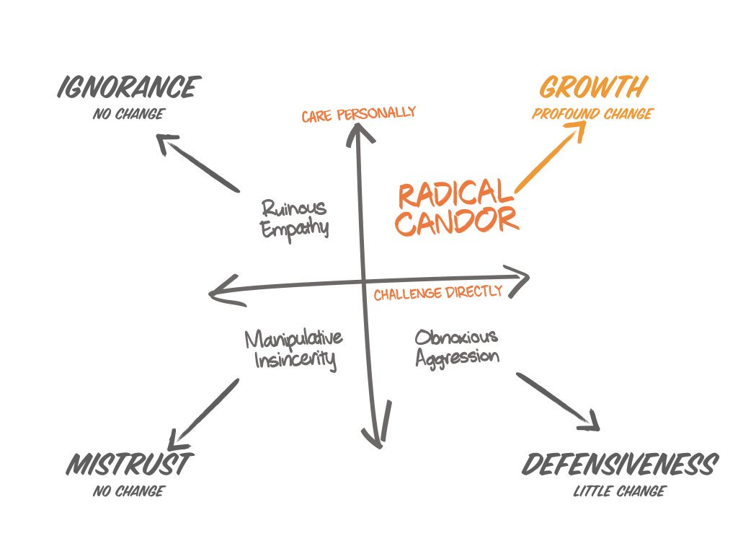
- In the past, I was a lot more hesitant to challenge, especially when the person was senior to me. I am more more candid as I get further in my career.
- Describe your work style. What techniques do you use for personal productivity?
- This has historically been dictated by my jobs. If I were to build a perfect day, I would do 3-4 hours of deep work in the morning and then spend afternoons doing more admin work.
- I like to bounce ideas and strategy off of someone at the outset of a project and then work independently from there. I think idea sharing and limiting silos is extremely important. I really like daily sprint check ins. Quick iteration and high velocity.

- If you were to pick what you would be doing 10 years from now, what would you guess?
- A business owner of some kind. As long as I am at the intersection of execution and strategy, I tend to be happy. Having flexibility and freedom of time is very important to me.
What motivates you?
- Why do you want to start a company — in general, and in particular right now?
- I think the time is right with the experience I have. I have had the entrepreneurial itch for some time and feel ready to get after it after exploring and challenging limiting beliefs.
- What is success to you? What motivates you personally?
- Success to me is contentness, taking care of my health, having strong relationships, and achieving in business to my potential. I am motivated intrinsically by executing to the potential I know I have. I like to stretch myself and have a growth mindset.
- Who do you admire most in your organization/family/friends and why?
- In organizations I admire radical candor, respect, and talent density. I like when a company executes in pursuit of its goals while respecting the humanity of all stakeholders internally and externally.
- In family and friends, I admire emotional intelligence, integrity, and reliability/showing up. People who are there for you in bad times and proud/not jealous in good times are a rare breed.
- What are you most proud of in your work career or life to date?
- In my career, I am most proud of the teams I have built and the people I have managed. I take people management very seriously and am cognizant of how difficult corporate America can be. It is important to me to build teams with diversity of backgrounds and diversity of thought. I want the people I’ve managed to feel I have been a champion in their corner.
What do you want?
- What impact do you want to have?(i.e. is your startup objective “getting rich” or “changing the world”?)
- After a certain level of money, I am really interested in making an impact on the companies we serve and the employees we hire.

- Is control or success more important?(i.e. Are you willing to step aside if the company is more likely to have a financially successful outcome? or is it important for the founders to stay in control of the company’s destiny?
- Success

- Is it possible to build a wildly successful company without burning out or damaging other parts of your life (family, health, etc.)?
- Yes, but it requires systems and understanding when to outsource work. I DO NOT want to build myself a high stress job.
Logistical Questions
- How should founder equity be set? What’s your philosophy on the employee equity pool?
- 50/50. Open to setting a portion aside but haven’t done research on what this typically looks like.
- What should our approach to employee compensation be, including cash and equity?
- 75%ile to attract high performers. Open to employee equity program.

- What does an ideal company exit look like to you? (i.e. “work on company for 1-2 years and sell for 7 figures” to “work for 10+ years, reach 9 figures in revenue, and IPO”)
- Sell in 5ish years for 10+M

- How do you think about the timeframe and pace of success? Are you willing to take the longer path? How long is too long?
- Willing to go for 3 years as discussed

- What do we do if we find product/market fit, yet none of the founders are excited about that product?
- This might be a bit more focused on product vs. service
Commitment and Finances
- Will this company be your primary activity? Do you have any other time commitments?
- Yes. Family.

- What is your personal runway? Current burn rate? Would you invest your own money (ideally retaining higher equity in return)?
- One year with 0 revenue. I would invest my own money yes.
- What is the minimum monthly salary you need to survive? To be comfortable? To feel like you’ve “made it?”
- 7k/10k/20k+
- What should the policy of co-founders advising/consulting with other companies be?
- Open to it depending on particulars and how we’d carve it. But not direct competitive work.

